Microsoft Teams
Setup Guide
- To get set-up, please download the Microsoft Teams app through the following link:
https://products.office.com/en-ca/microsoft-teams/download-app

- Clicking the above link should redirect to this page on your default browser
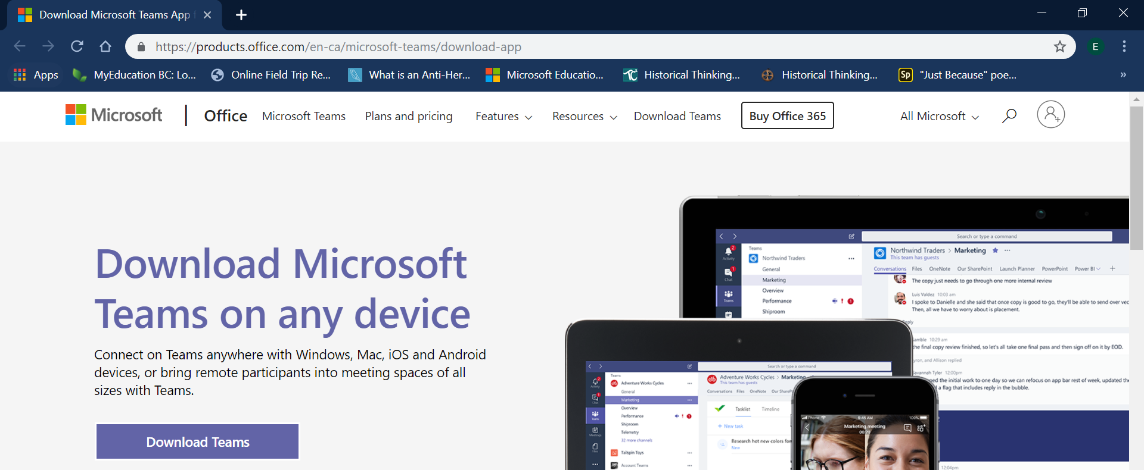
Click this

- Clicking that button should redirect you to this page:
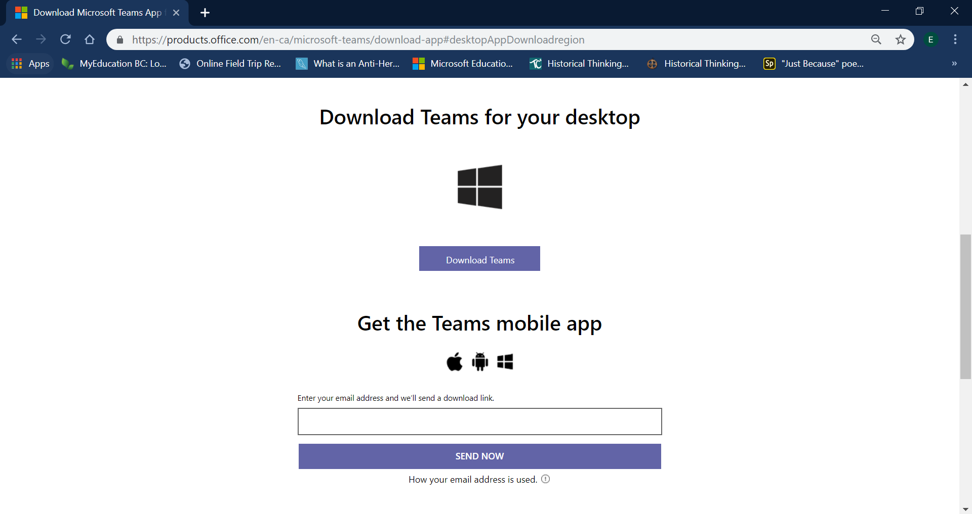
If you are using an iPad or other tablet device, enter your email here and click “Send Now”
Once you receive the email,
download the app using the sent link.
If you are a Windows computer user (PC or Laptop) click this

- After you’ve set-up Microsoft Teams, please open the app and sign-in using your SD43 email and password. Once you’re in, you’re all set-up!
