Imagery in poetry

How are poems like paintings and photographs? Poems are like paintings; they paint pictures with words. Poems are also like photographs, since they often try to capture a moment of time and freeze it for the future. Paintings and photographs are excellent sources of ideas for poems because they suggest characters, settings, plots, themes, and images.
Choose a picture or painting and write a poem based on the picture. You will need to find a picture and copy it to a word document; like the example on the next page. Write your poem below the image.
  - You can visit the following website for Canadian paintings and pictures.
https://www.gallery.ca/collection/search-the-collection
The poem may be in any form you choose. Ideas for getting started:
- Make up a “like what” list about something in the picture.
- Brainstorm a strong verbs list for the action taking place in the picture.
- Imagine yourself in the picture and use your senses to describe the sounds, smells, and textures of the scene.
- If there are people in the picture think about what they might be thinking, or what they might be saying to one another.

Please take a look at the example on the next page. Remember, I didn’t write it!

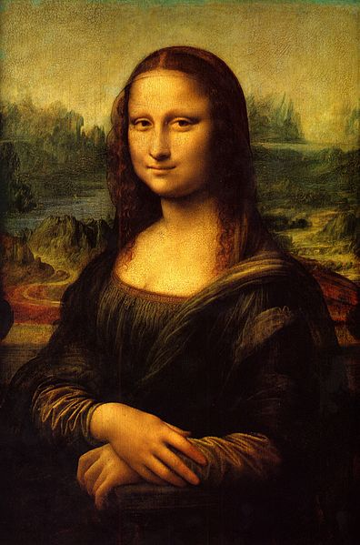

On Mona’s Smile
I know what brought
that expression to her face.
During one of her sittings
Leo said to her, “You know, Mona,
you’re very intelligent
for a woman.”
By Winana Baker

