Australopithecus  (Southern ape) | Homo Habilis  (Handyman) | Homo Erectus  (Upright man)
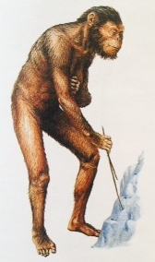 | 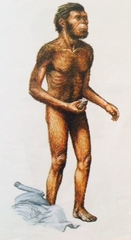 | 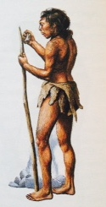
Approx. 1.2-4 million years ago | Approx. 2-1.5 million years ago | Approx. 1.6 million to 80 000 years ago
Basic Description:  - “Prehuman Huminoid”- not fully like human.  - Apelike- walked on 2 legs, not 4.  - Small brains and teeth similar to humans today. | Basic Description:  - Considered the first real human.  - Walked upright with long dangling arms.  - Not skillful hunters but ate meat if they found discarded carcasses. | Basic Description:  - Looked more like us than earlier humans did.  - They were as tall as we are, but stronger.  - Bigger brains than Homo Habilis, but couldn’t talk.
Tools:  - Used simple tools only.  - “Twigs” | Tools:  - Built shelters from branches and used stones as tools.  - Produced tools for chopping, scraping, and cutting by knocking stone flakes off hard stones.  - “Choppers” | Tools:  - Made complex tools, including hand axe and tools for butchering.  - These tools allowed them to hunt game from Africa to Asia.  - “Hand axes”
Additional Facts: | Additional Facts:  - “Handyman” was one of first humanoids to use tools.  - The Stone Age refers to the materials used to make man-made tools.  - Hunters and Gatherers (didn’t plant crops) | Additional Facts:  - Evidence shows that “Upright Man” learned how to make fire.  - Able to cook food- helped reduce disease.  - Fire helped build sense of community.

Homo Sapiens  (Neanderthal) | Homo Sapiens  (Cro-Magnon) | Homo Sapiens Sapiens  (Modern humans)
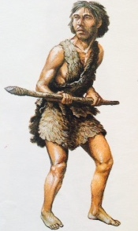 | 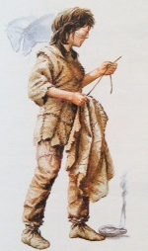 | 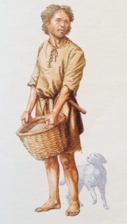
Approx. 133 000 to 32 000 years ago | Approx. 100 000 to 10 000 years ago | Approx. 10 000 years ago to the present
Basic Description:  - “Sapiens”- means thinking.  - Neanderthals were smarter than earlier humans. | Basic Description:  - Another group of Homo sapiens.  - Had even bigger brains and real capacity for complex thinking. | Basic Description:  - “Homo sapiens sapiens” is the species to which modern-day people belong.  - Evidence of these humans first appeared in Africa.
Tools:  - They made stone knives, a process that takes 9 steps and 250 blows.  - Built shelters and other structures to protect themselves.  - Also made throwing weapons such as harpoons and spears.  - “Blades” | Tools:  - Invented a variety of tools to hunt and fish, paint, draw, sew, make music and fight with others.  - Made fish hooks and needles from antlers.  - “Specialized tools” – bow and arrow  - Painted wall drawings in caves. | Tools:  - Superior tool-making skills.  - Besides precisely made tools modern humans developed their tool-making skills in other areas- such as weaving baskets from reeds.  - “Harpoons”
Additional Facts:  - First people to bury their dead.  - Used caves as homes. | Additional Facts:  - Named after a place they were first found in France.  - Burial sites contained objects such as beads, fur garments, and ivory jewelry. This suggests that Cro-Magnon lived at least part of the year in a community. | Additional Facts:  - Survived the last Ice Age and went on top populate the earth.  - Only with Homo sapiens sapiens did human civilization finally become possible.

